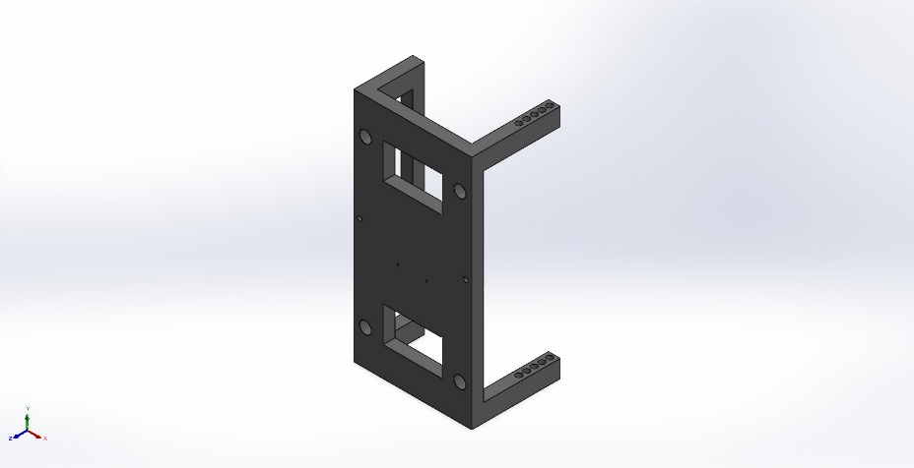
  Simulation of Main Body
  Date: 5 Ocak 2026 Pazartesi
  Designer: Solidworks
  Study name: Static 1
  Analysis type: Static
  Table of Contents
  Description 1
  Assumptions 2
  Model Information 2
  Study Properties 3
  Units 3
  Material Properties 4
  Loads and Fixtures 4
  Connector Definitions 5
  Interaction Information 5
  Mesh information 6
  Sensor Details 7
  Resultant Forces 8
  Beams 8
  Study Results 9
  Conclusion 11

Description
No Data

Assumptions

Model Information

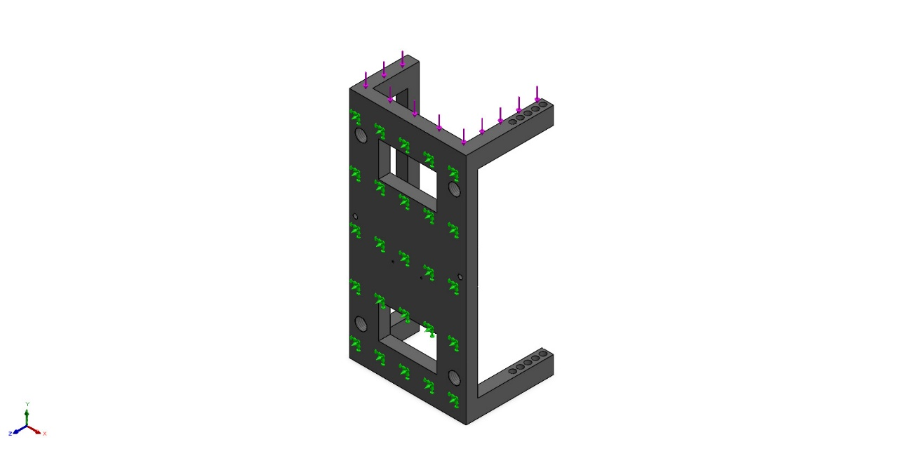
Model name: Main Body
Current Configuration: Default
Solid Bodies
Document Name and Reference | Treated As | Volumetric Properties | Document Path/Date Modified
Mirror1  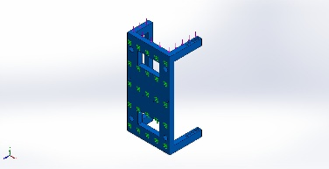 | Solid Body | Mass:2,35535 kg  Volume:0,0016945 m^3  Density:1.390 kg/m^3  Weight:23,0825 N | C:\Users\victus tr\OneDrive\Masaüstü\Kmd project\Main Body.SLDPRT  Jan 4 20:11:04 2026

Study Properties
Study name | Static 1
Analysis type | Static
Mesh type | Solid Mesh
Thermal Effect: | On
Thermal option | Include temperature loads
Zero strain temperature | 298 Kelvin
Include fluid pressure effects from SOLIDWORKS Flow Simulation | Off
Solver type | Automatic
Inplane Effect: | Off
Soft Spring: | Off
Inertial Relief: | Off
Incompatible bonding options | Automatic
Contact penalty stiffness scale factor | 1
Large displacement | Off
Compute free body forces | On
Friction | Off
Use Adaptive Method: | Off
Result folder | SOLIDWORKS document (C:\Users\victus tr\OneDrive\Masaüstü\Kmd project)

Units
Unit system: | SI (MKS)
Length/Displacement | mm
Temperature | Kelvin
Angular velocity | Rad/sec
Pressure/Stress | N/m^2

Material Properties
Model Reference | Properties | Components
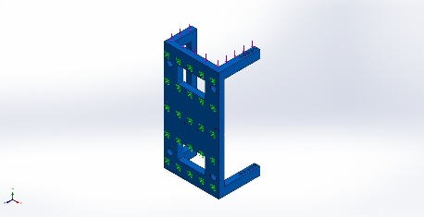 |  | SolidBody 1(Mirror1)(Main Body)
  Name: | POM Acetal Copolymer
  Model type: | Linear Elastic Isotropic
  Default failure criterion: | Unknown
  Tensile strength: | 7,15e+07 N/m^2
  Elastic modulus: | 2,6e+09 N/m^2
  Poisson's ratio: | 0,3859
  Mass density: | 1.390 kg/m^3
  Shear modulus: | 9,328e+08 N/m^2
Curve Data:N/A

Loads and Fixtures
Fixture name | Fixture Image | Fixture Details
Fixed-1 | 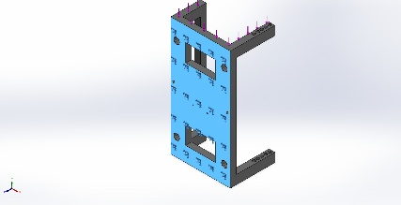
  Entities: | 1 face(s)
  Type: | Fixed Geometry
Resultant Forces
Components | X | Y | Z | Resultant
Reaction force(N) | -0,155434 | 1.000,08 | 0,15987 | 1.000,08
Reaction Moment(N.m) | 0 | 0 | 0 | 0

Load name | Load Image | Load Details
Force-1 | 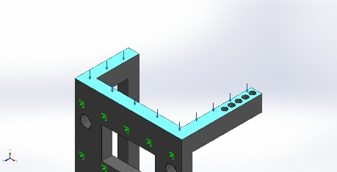
  Entities: | 1 face(s)
  Type: | Apply normal force
  Value: | 1.000 N

Connector Definitions
No Data

Interaction Information
No Data

Mesh information
Mesh type | Solid Mesh
Mesher Used: | Blended curvature-based mesh
Jacobian points for High quality mesh | 16 Points
Maximum element size | 23,849 mm
Minimum element size | 1,19245 mm
Mesh Quality | High

Mesh information - Details
Total Nodes | 31311
Total Elements | 18509
Maximum Aspect Ratio | 6,7677
% of elements with Aspect Ratio < 3 | 96,1
Percentage of elements with Aspect Ratio > 10 | 0
Percentage of distorted elements | 0
Time to complete mesh(hh;mm;ss): | 00:00:03
Computer name: | VICTUSINYO

Mesh Quality Plots
Name | Type | Min | Max
Quality1 | Mesh | - | -
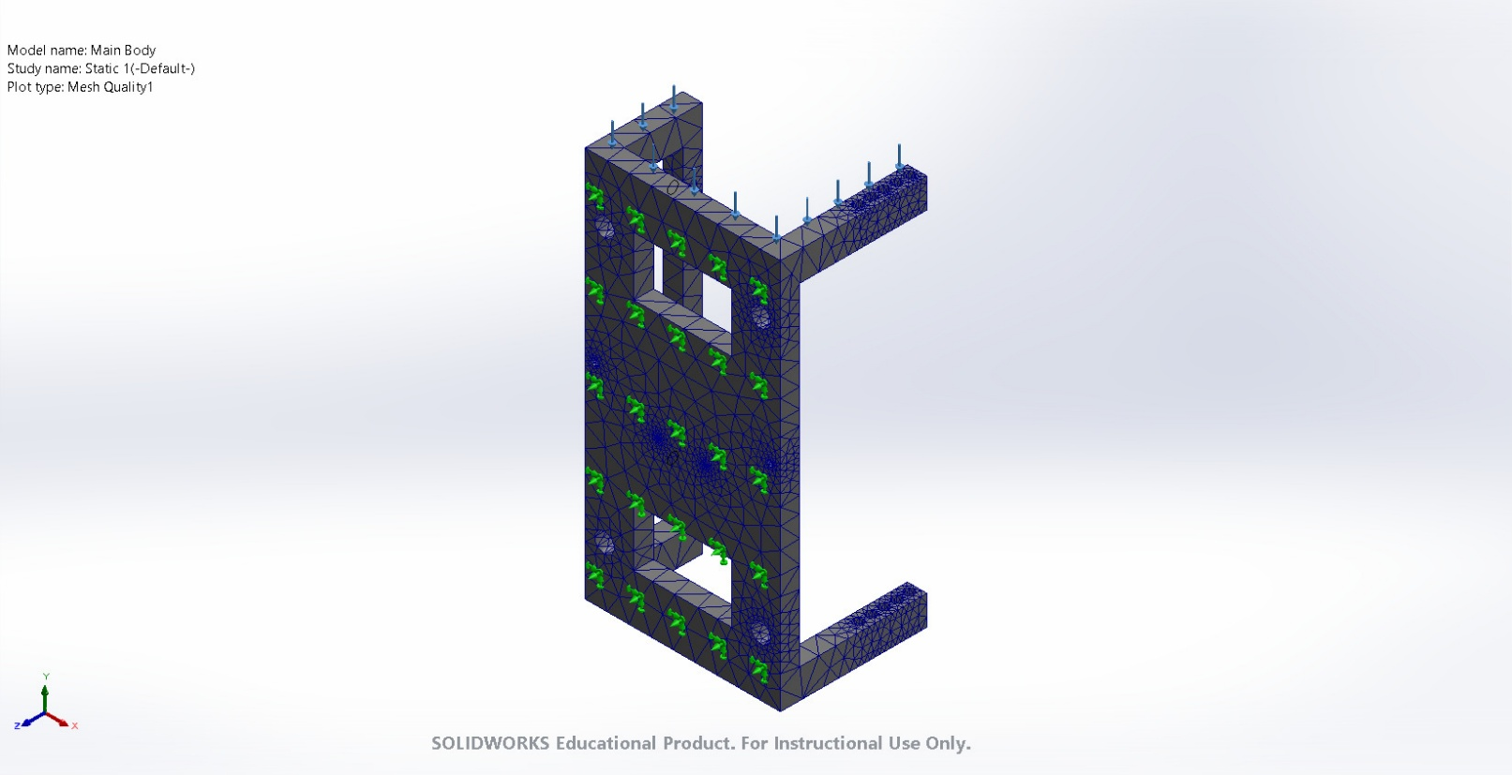
Main Body-Static 1-Quality-Quality1

Sensor Details
No Data

Resultant Forces

Reaction forces
Selection set | Units | Sum X | Sum Y | Sum Z | Resultant
Entire Model | N | -0,155434 | 1.000,08 | 0,15987 | 1.000,08

Reaction Moments
Selection set | Units | Sum X | Sum Y | Sum Z | Resultant
Entire Model | N.m | 0 | 0 | 0 | 0

Free body forces
Selection set | Units | Sum X | Sum Y | Sum Z | Resultant
Entire Model | N | -1,04055 | 0,453825 | -0,0323126 | 1,13567

Free body moments
Selection set | Units | Sum X | Sum Y | Sum Z | Resultant
Entire Model | N.m | 0 | 0 | 0 | 1e-33

Beams
No Data

Study Results

Name | Type | Min | Max
Stress1 | VON: von Mises Stress | 7,705e-05N/m^2  Node: 27892 | 5,508e+06N/m^2  Node: 9717
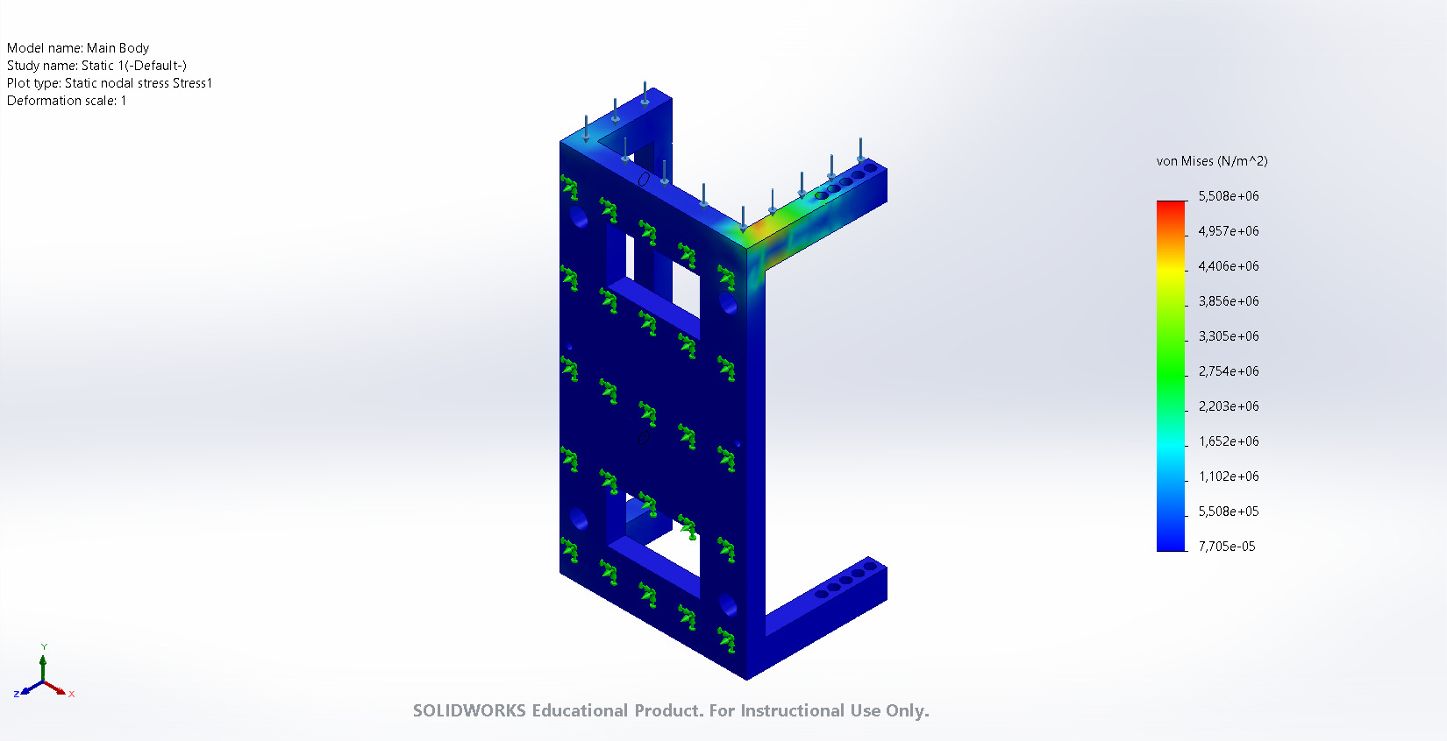
Main Body-Static 1-Stress-Stress1

Name | Type | Min | Max
Displacement1 | URES: Resultant Displacement | 0,000e+00mm  Node: 1 | 8,427e-01mm  Node: 10
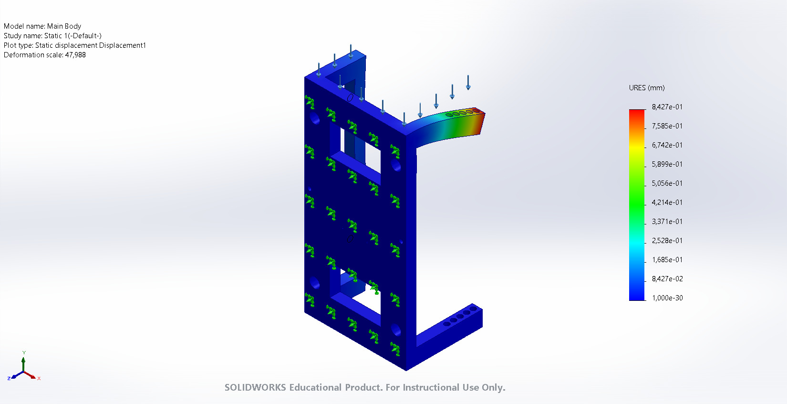
Main Body-Static 1-Displacement-Displacement1

Name | Type | Min | Max
Strain1 | ESTRN: Equivalent Strain | 1,512e-14  Element: 18063 | 1,524e-03  Element: 13237
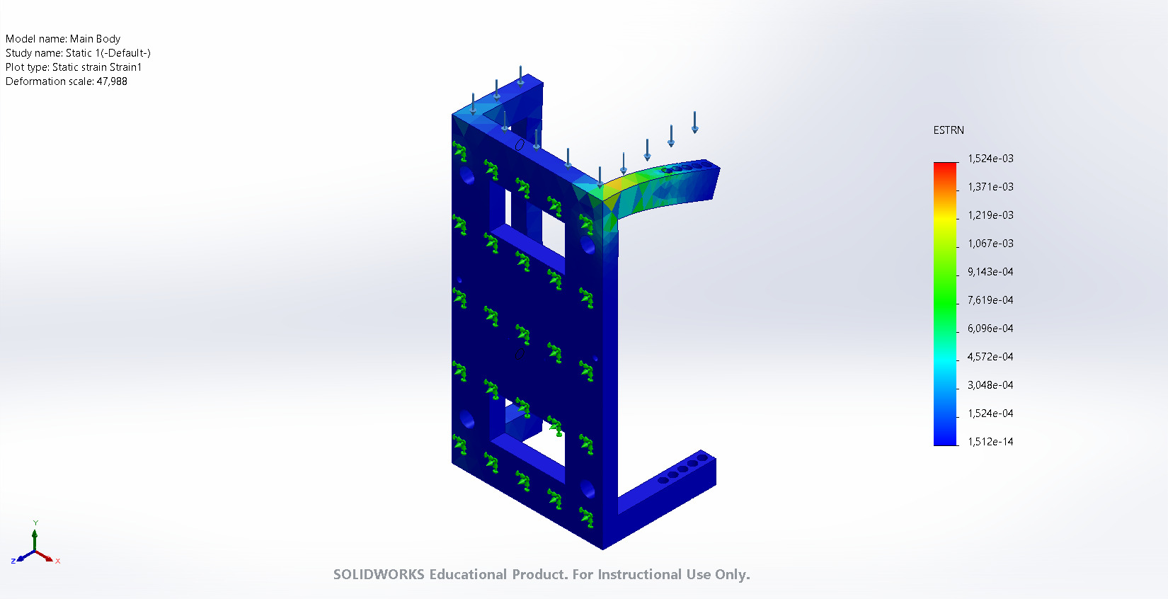
Main Body-Static 1-Strain-Strain1

Conclusion

